Game Design Document

Fill up the following document

1. Write the title of your project.

Piano tiles

1. What is the goal of the game?

To not miss out on any tiles and get the highest score.

1. Write a brief story of your game.

The story can be interpreted differently by each individual playing the

Game.

1. Which are the playing characters of this game?

* Playing characters are the ones who respond to the user based on the input from the user.
* Cars, monkeys, dinos, wizards, etc., are the playing characters in the game.

|  |  |  |
| --- | --- | --- |
| Number | Character Name | What can this character do? |
| 1 | Tiles | Moves from top to bottom |
| 2 |  |  |
| 3 |  |  |
| 4 |  |  |
| 5 |  |  |
| 6 |  |  |
| 7 |  |  |
| 8 |  |  |

1. Which are the Non-Playing Characters of this game?

* Non-Playing characters are the ones that don't have an action or behavior when the user interacts with the game.
* Hurdles, stones, bananas, coins, etc., are non-playing characters in the game.

|  |  |  |
| --- | --- | --- |
| Number | Character Name | What can this character do? |
| 1 | none |  |
| 2 |  |  |
| 3 |  |  |
| 4 |  |  |
| 5 |  |  |
| 6 |  |  |
| 7 |  |  |
| 8 |  |  |

Draw your imagination of this game. What does this game look like?

* Draw the game either on your computer or on paper.
* Add images of the game scenes to show each of the playing and non-playing characters at least once.

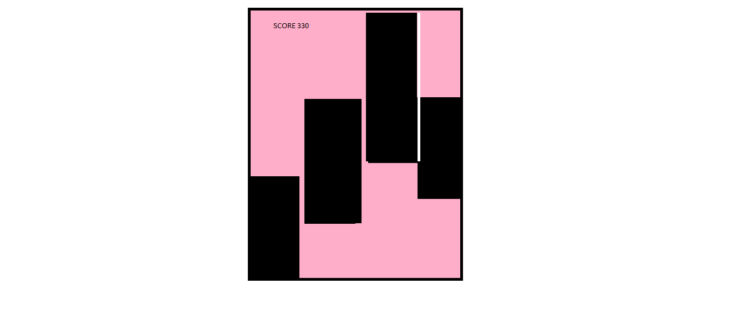

How do you plan to make your game engaging?

In case you miss out on any tile and couldn’t score the highest then you can take another turn.The music in the game is what makes it more addictive.